

2/14/2021

To whom it may concern,

This is a letter of recommendation on behalf of Anastasia Ignashkina  
Anastasia is currently enrolled in my Multivariable Calculus class, which I am offering in synchronous remote modality via Zoom. We have not done any test yet, but based on homework, attendance, and participation in the class activities, I can state that Anastasia is in the top 10% of my class, and I trust that the first test will confirm the good impression I have of her. I have met with Anastasia several times during my office hours, and I could verify that she works efficiently and learns quickly. This semester she is taking five hard classes and she is doing well in all of them. More importantly, she is not one of the students who is content with easy recipes on how to do problems, but she wants to understand the motivations behind them. She plans to major in Biochemistry, but I believe she could be also very good in Mathematics. Anastasia’s personality is very pleasant, and her international background and experience made her more mature and responsible than her average peers. She has good leadership quality, and she is the life and soul of her study group. I strongly recommend Anastasia for the position for which she is applying.

Should you require further information, please do not hesitate to contact me.

Sincerely,

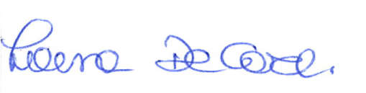

Professor of mathematics  
Florida International University Mathematics and Statistics, DM 418 Miami (FL) 33199  
web: faculty.fiu.edu/~decarlil

College of Arts, Sciences, and Education  
Department of Mathematics and Statistics  
11200 S.W. 8th St. + Modesto A. Maidique Campus, DM 430 + Miami, FL 33199 + Tel 305-348-3769